https://sway.office.com/gxrY2VQh6xIt45o6?ref=Link

The Role of Online Forum Support in Understanding and Accepting Chronic Pain Status



# The Inspiration and Existing Research

Chronic pain is a multifactorial condition with biological, psychological, and social factors contributing to its experience. Online health forums are a common source of support and information for those with chronic illnesses however, there is limited research focusing on online chronic pain communities despite the demonstrated importance of social support for those with chronic pain.

Previous research, such as that of Attard and Coulson (2012), and Crump and LaChapelle (2022) use messages from online health forums as qualitative data for thematic analysis, in Parkinson's disease and fibromyalgia online communities respectively. This innovative methodology inspired the design of this study.

# The Current Study

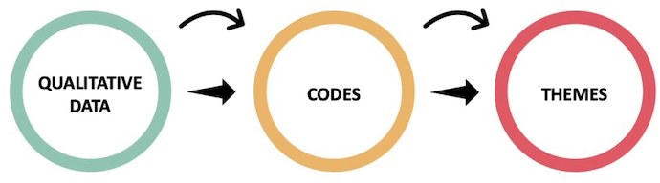

The primary objective of this study was to explore the role of online health forums in the affordance of peer support to individuals with chronic pain.

Two research questions guided this investigation,

Q1 ‘How do people with chronic pain use online forums to inform their chronic pain understanding?’, and the second,

Q2 ‘How do individuals gain an acceptance of chronic pain status through online peer support?’

These questions were explored through the inductive thematic analysis of messages exchanged on the online chronic pain forum, PainSupport.

The use of messages and discussions from an online pain forum as a data source offers a unique insight into the experiences of users of the forum. The worth of these forum analyses is exemplified by their growing usage in qualitative research.

# The Results



The findings of this study revealed that involvement with the forum was valuable in enhancing a personal understanding of pain and in encouraging an acceptance of pain, specifically through 'enhancement of pain literacy', 'experience sharing', and 'emotional support'.

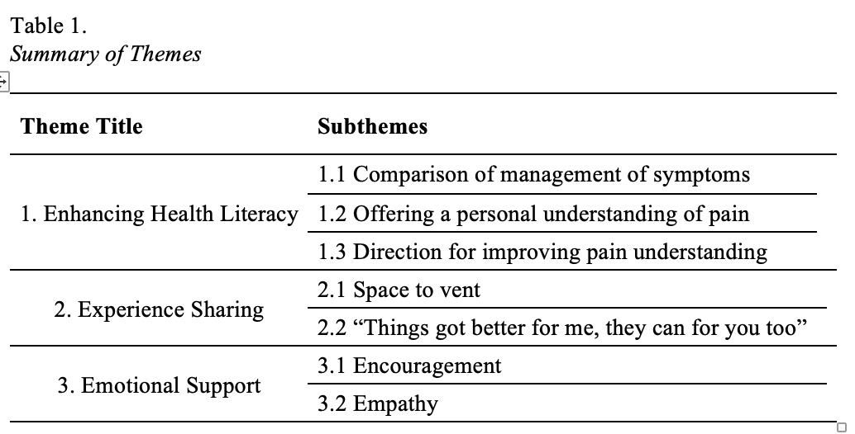

These results support those of previous research into peer support provided on online health forums, offer novel insights into the mechanisms for improving an understanding and acceptance of pain and support and inform the Biopsychosocial Model and Optimal Matching Theory’s application to chronic pain.

# Next Steps

Whilst thematic analysis of forum posts offered a unique position to explore and interpret the experiences of individuals with chronic pain online, members of the forum did not get the opportunity to provide their insights and opinions on the research questions.

It would therefore be valuable to carry out a prospective study potentially using questionnaires to explore members opinions of online pain forum peer support.

Furthermore, Although the current research provided valuable insights into the mechanisms of peer support on online chronic pain forums, it also raised various questions which would require future investigation.

Primarily it raises the question of the suitability of the involvement of health professionals as moderators on these sites and if this upsets peer support structures.

# References

Attard, A., & Coulson, N. S. (2012). A thematic analysis of patient communication in Parkinson’s disease online support group discussion forums. Computers in Human Behavior, 28(2), 500-506.

Crump, L., & LaChapelle, D. (2022). “My Fibro Family!” A qualitative analysis of facebook fibromyalgia support groups’ discussion content. Canadian Journal of Pain, 6(1), 95-111.

https://sway.office.com/gxrY2VQh6xIt45o6?ref=Link